Interactive Lessons # 3 - Electrical Circuits
Calculus Physics 2

We will be using the University of Colorado’s physics simulations called PhET interactive simulations in Physics

Go to the link below
Go to the phet.colorado.edu simulation: Circuit Construction Kit: DC - Virtual Lab (colorado.edu)

Start the simulation “Circuit Construction Kit: DC – Virtual Lab
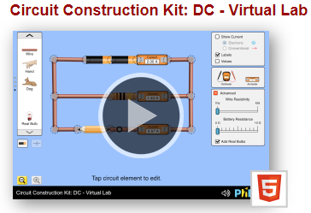

Overview of Simulation

- The Virtual Lab is shown below with the circuit components on the right and the Voltage meter and Current meter (Ammeter) on the left
- Use “Conventional” to show the “+” current flow on the upper right side.
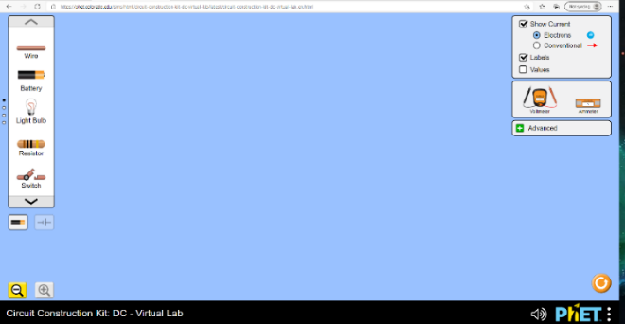

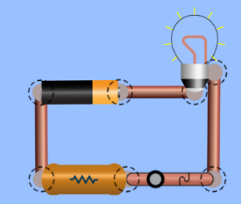
- On the right are the circuit components, left click and drag and drop a component on to the work area, a dashed red circle will appear on either end, this is where the other components will be connected. Once connected the circle will turn black.
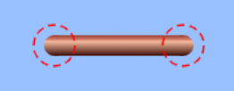

- The components can be moved by Click and dragging, click/drag one side will change the direction of the component.
- To disconnect a circuit element, click on the black circles at a connection, yellow scissors will appear, click on these will break the connection.

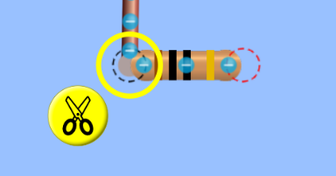

- Clicking on the center of the battery or resistor will allow you to change the value of that component.
- The battery is the power supply for the circuits in this simulation.

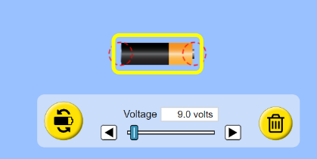
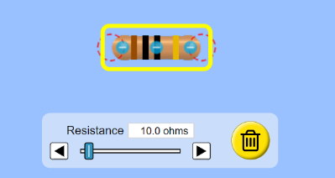

- Use the plain battery, voltage range is 0 V to 120 V!
- The Battery with the yellow triangle has a voltage range of 100 V to 100,000 V
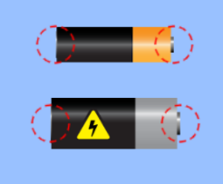

- The Ammeters are placed in the cirucit similar to a cirucit compoents such as a light bulb or resistor.
- The Voltage meter reads the voltage when the probes are placed at each connection across the component.
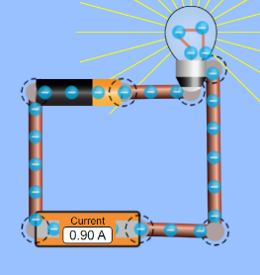
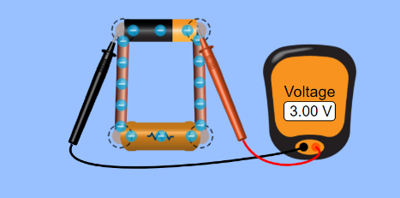

- For resistances (between 10 Ω to 120 Ω) use the resistor with the Brown, Black, Black stripes.
- For higher resistances (1,000 Ω (1kΩ) and up) use the resistor with the resistor symbol

10 to 120 Ω 1kΩ and up
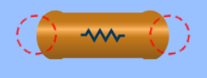
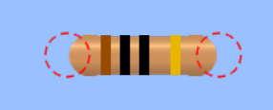

Experiment # 1 - Light Bulb and resistor in series

Wire a single light bulb in series with a resistor, light bulb and a current meter as shown. Make sure the “Conventional” current will appear in the circuit.
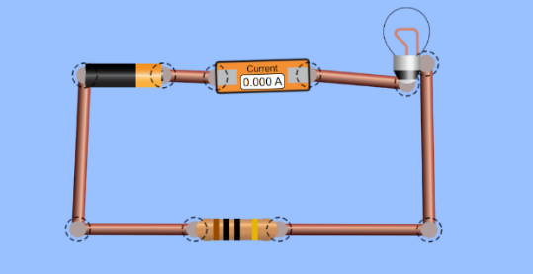
To adjust potential of the battery - Click on the center of the battery so that the voltage control for the battery is shown at the bottom of the simulation.


- Slowly move the voltage up from 0 V to 120 V, what is happening to the movement of charge, explain why this would be happening?

- What does this movement of charge as the voltage goes up mean for the value of the current, explain?

- Is the movement of charge the same throughout the circuit, going into the bulb coming out of the bulb, what does this tell you about the current at any point in the circuit?

- How does the reading on the current meter change with voltage/current?

- How does the brightness of the bulb change as the voltage is increased?

- Light is energy, explain source of the light energy and why it gets brighter when the voltage is increased, explain in terms of the potential, charge and current?

Set the battery’s voltage to 30 V


- Note the current value, click on the “flip battery icon”, this will change the positive pole to the negative pole, describe what happens in the circuit when flipped and does the brightness of the bulb or current change?

- Flip the battery back to its original position before moving on!

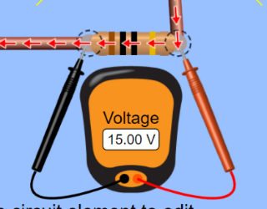
Changing the resistance in a circuit – Set the voltage of the battery to 30 V, place a voltage meter across the resistor as shown and then click on the resistor. Place a second voltage meter across the light bulb as shown, make sure the red probe is on the incoming current side and the black probe is on the outgoing current side.

Set the resistance of the resistor to 10 Ω, note that the light bulb has a resistance of 10 Ω.
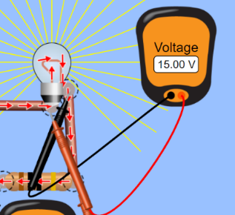
- How does the voltage across the light bulb compared to the voltage across the resistor, does this make sense?

- How does the sum of the voltage across the light bulb and resistor compared to the voltage the battery is set? Why would this be the case?

- Change the resistance of the resistor to 40 Ω, how do the voltages compare (resistor and bulb) and do they sum to the voltage of the battery? Explain.

- Why would the resistor have a larger voltage across it than the bulb when the resistor was changed to 40 Ω?

- Validate that the sum of the potentials in a circuit equals the potential of the power source one more time by increasing the resistances and show the battery voltage is equal to the sum of the potentials across the bulb and resistor. Show your work below.

Experiment # 2 – Series and parallel circuits (3 Light)

- Using the 3 light bulbs in the simulation that have a resistance of 10 Ω (check value by clicking on bulb by clicking on the bulb) and a 30 V battery, wire each circuit below and answer the question using your results. You do not need the current meter or the resistor. You will need the volage meter when asked.

Wire the three bulbs in series as shown – Keep the battery voltage at 30 V
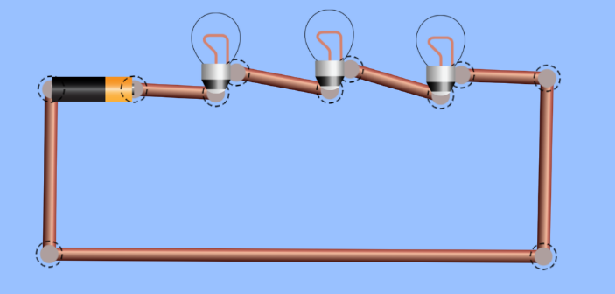
V_{dc}
B₁
B₂
B₃
Figure 1

- In Figure 1, all the bulbs are exactly the same, rank their brightness from least to greatest or equal. Explain why this would be the case.

- Using the voltage meter to measure the potential across each of the bulbs, how do they compare?

- If bulb 1’s resistance is increased to 120 Ω (max for bulb in simulation) what happens to the brightness of the bulbs 1, 2 and 3. Click on the bulb and change the resistance. Explain why?

- Using the voltage meter, measure the potential across each of the bulbs with the bulb’s resistance changed, what has changed in the voltage reading and why?

- Break the circuit by clicking on one of the junctions where the wires are connected by clicking on the scissors. What happens to the brightness of the bulbs?

- Make sure all the resistance of the bulbs is reset to 10 Ω!
Now wire the bulbs in parallel as shown – Keep the battery voltage at 30 V
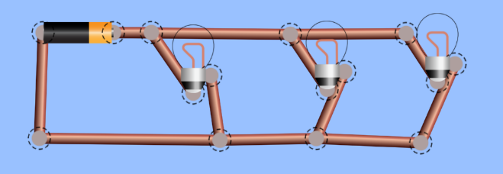
V_{dc}
B₂
B₃
B₁
Figure 2

- In Figure 2, all the bulbs are exactly the same, rank their brightness from least to greatest or equal.

- Using the voltage meter to measure the potential across each of the bulbs, how do they compare?

- If bulb 1’s resistance is increased to 120 Ω (max for bulb in simulation) what happens to the brightness of the bulbs 1, 2 and 3? Click on the bulb # 1 and change the resistance. Explain why?

- Using the voltage meter, measure the potential across each of the bulbs with the bulb’s resistance changed, what has changed in the voltage reading and why?

- Break the circuit at one bulb by clicking on one of the junctions where the wires are connected and click on the scissors. What happens to the brightness of each bulb?

- If the voltage in Figures 1 and 2 are the same, how did the brightness of the bulbs in Figure 1 (series circuit) compared to the bulbs in Figure 2 (parallel circuit)? Explain why?

- Make sure all the resistance of the bulbs is reset to 10 Ω!
Experiment # 3 - Circuit with both series and parallel - Keep the battery voltage at 30 V

Wire the first bulb in series with the other two bulbs in parallel as shown below
V_{dc}
B₁
B₂
B₃
Figure 3
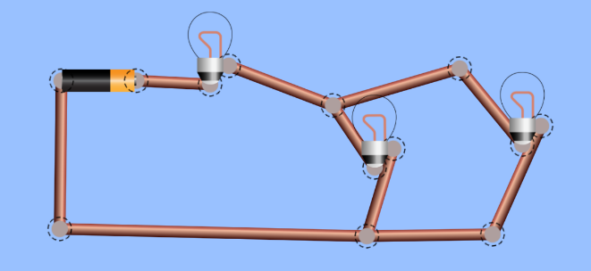

- In Figure 3, all the bulbs are exactly the same, rank their brightness from least to greatest or equal. Explain why you ranked them in this way. Check your answer using the circuit you have wired.

- Using the voltage meter to measure the potential across each of the bulbs, how do they compare and why?

- How does the potential across the brightest bulb(s) compared to the potential across the bulb(s) with the smaller potential across it and does this make sense?

- When complete Upload this Lesson to this assignment

